Database Storage

Definition
# Source: AI Source: Provided by: [Data Path: Persons Table -> ID Column: 1, Name_En Column: Motasem Essam] -> From: [Chatgpt (GPT‑5 Mini)] on [12/10/2025]
Database storage is a method of storing data in a structured system (database) that allows it to be organized, managed, and accessed efficiently.
- Data is stored in tables with rows and columns.
- Databases support querying, updating, and indexing for fast access.

Key idea:
# Source: AI Source: Provided by: [Data Path: Persons Table -> ID Column: 1, Name_En Column: Motasem Essam] -> From: [Chatgpt (GPT‑5 Mini)] on [12/10/2025]
A database is like a digital filing cabinet, where each table is a drawer, and each row is a file that can be found quickly.

Characteristics of Database Storage
# Source: AI Source: Provided by: [Data Path: Persons Table -> ID Column: 1, Name_En Column: Motasem Essam] -> From: [Chatgpt (GPT‑5 Mini)] on [12/10/2025]
- Structured format: Data is organized into tables (rows and columns).
- Efficient access: Databases use indexes for quick search.
- Supports large data: Can store millions of records.
- Secure and reliable: Supports permissions, backups, and data integrity.
- Relational or Non-relational:
  - Relational Databases (RDBMS) → SQL-based, structured tables
  - Non-relational Databases (NoSQL) → JSON, key-value, or document-based

Example
# Source: AI Source: Provided by: [Data Path: Persons Table -> ID Column: 1, Name_En Column: Motasem Essam] -> From: [Chatgpt (GPT‑5 Mini)] on [12/10/2025]
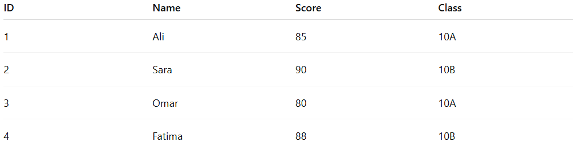
Students Table in a Database:
ID | Name | Score | Class
1 | Ali | 85 | 10A
2 | Sara | 90 | 10B
3 | Omar | 80 | 10A
4 | Fatima | 88 | 10B
- Query: SELECT * FROM Students WHERE Class='10A'
- Database retrieves Ali and Omar’s rows efficiently using indexes.

Advantages
# Source: AI Source: Provided by: [Data Path: Persons Table -> ID Column: 1, Name_En Column: Motasem Essam] -> From: [Chatgpt (GPT‑5 Mini)] on [12/10/2025]
- Quick access to data using queries and indexes
- Can handle large amounts of data
- Supports data relationships (foreign keys, joins)
- Easy to update and maintain data

Disadvantages
# Source: AI Source: Provided by: [Data Path: Persons Table -> ID Column: 1, Name_En Column: Motasem Essam] -> From: [Chatgpt (GPT‑5 Mini)] on [12/10/2025]
- Complex setup requiring knowledge of database design and administration
- High-end databases may need expensive servers or software
- Backup, indexing, and optimization must be regularly managed
- Some relational databases can struggle with very large or unstructured datasets
- Without proper replication or backup, data loss is possible

Example Section
# Source: AI Source: Provided by: [Data Path: Persons Table -> ID Column: 1, Name_En Column: Motasem Essam] -> From: [Chatgpt (GPT‑5 Mini)] on [12/10/2025]
A school stores student records in a relational database.
When a teacher wants all students in Class 10A, the database retrieves the records instantly, without scanning the entire dataset manually.

ID | Name | Score | Class
1 | Ali | 85 | 10A
3 | Omar | 80 | 10A
Because the data is structured and accessible through queries, this is database storage.

